Use the built-in iOS mail app
- Tap Settings > Mail, Contacts, Calendars >Accounts > Add account > Email.
- In the Add Account page, tap Exchange.
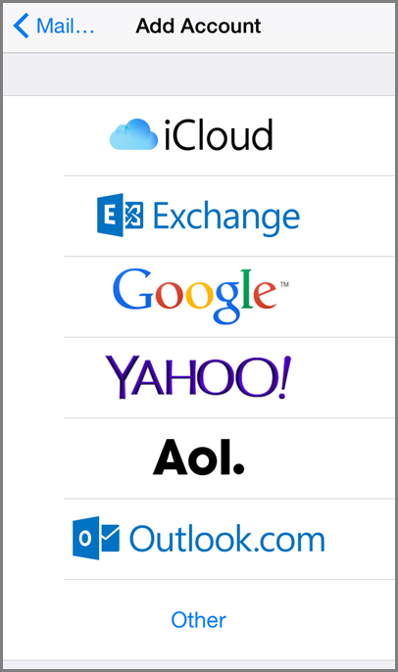
- Enter your full email address, for example username@bellmore-merrick.k12.ny.us, and your password, and then tap Next.
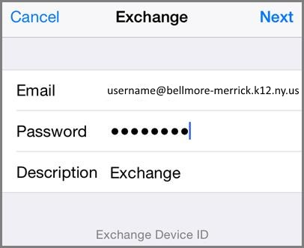
- By default, Mail, Contacts, and Calendar information are synchronized. Tap Save.
- Some versions of Apple IOS require one additional step. Please enter in your full email address for Email, outlook.office365.com for the Server, full email address for Username and your password.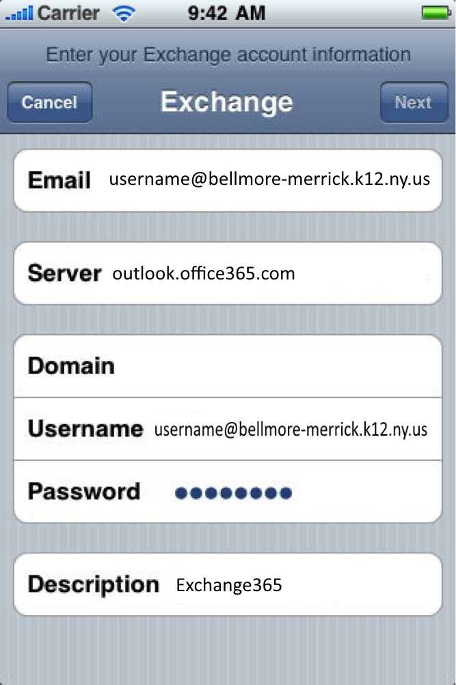
- If you're prompted to create a passcode, tap Continue and type a numeric passcode. If you're prompted and don't set up a passcode, you can't view this account on your device. You can also set up a passcode later in your settings.
Not working? Make sure you entered your email and password correctly and try again. You can also try setting the account up manually following the steps in the section Set up IMAP or POP email accounts, but selecting this method will only add your email, not your calendar or contacts.
Learn about other Office 365 resources for iOS in the See Also section at the bottom of this page.

